|  |
| --- |
| Markel Corporation |
| Underwriter Workbook One Time Analysis |
| P&L and Time Savings |

|  |
| --- |
| Dommalapati, Abhinay – Information Management Intern  7-25-2019 |

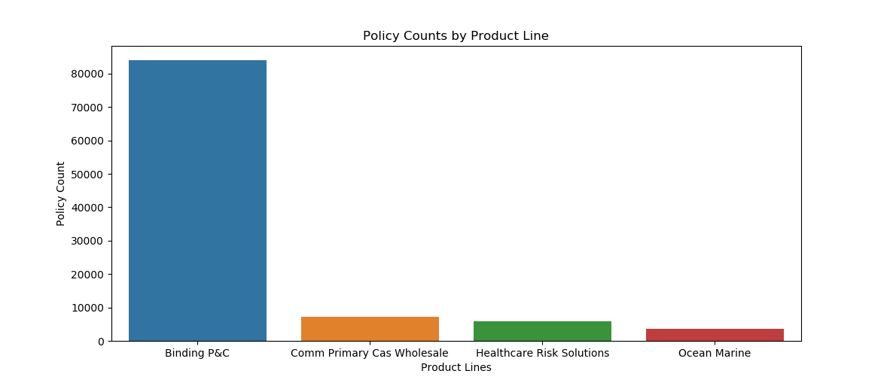Product Lines Exploratory Data Analysis

* 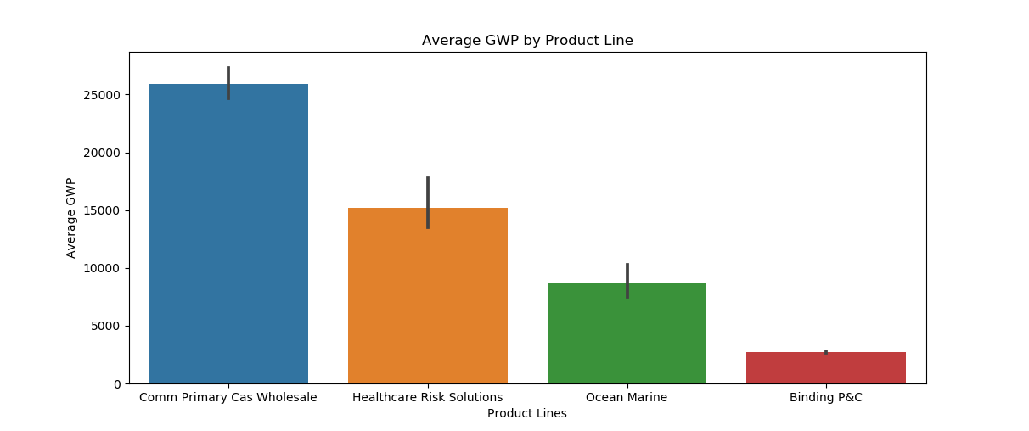Total number of policies impacted by the workbook (excluding binding P&C) is ≈ 17,000
* Commercial policies are the most expensive with respect to average GWP
* Total GWP impacted by the workbook (excluding binding P&C) is ≈ $300,000,000
* 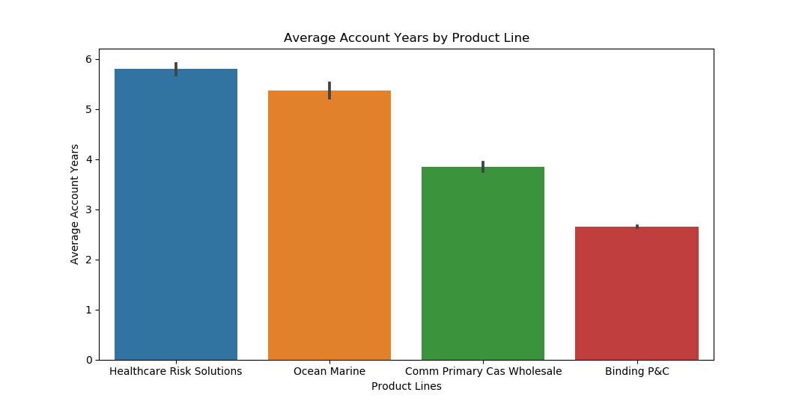In all product lines, the average length of the accounts exceeds 2 years
* 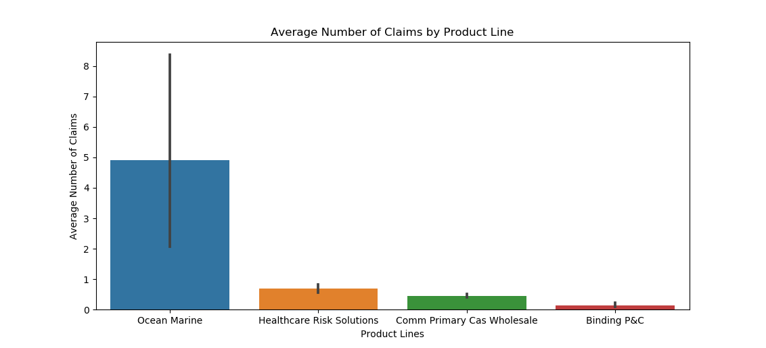Providing account history in the workbook removes the difficulty of looking through different data sources faced by the underwriters
* Policies with Claims and do not pass XRO Analysis
* 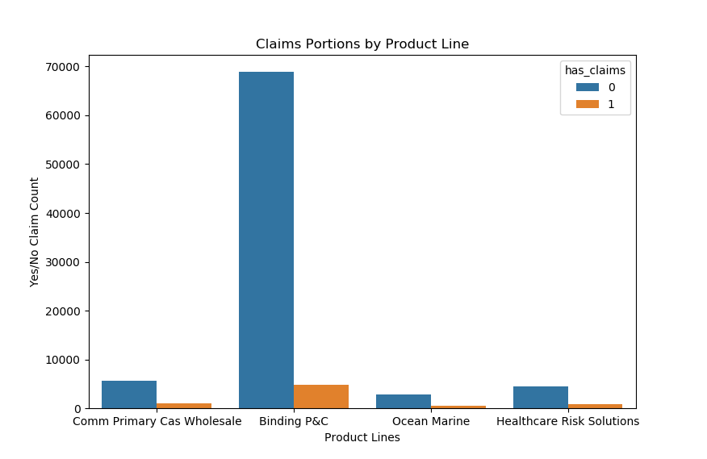Claims Portions
  + Binding P&C ≈ 6.5%
  + Commercial Primary Casualty Wholesale ≈ 14.7%
  + Healthcare Risk Solutions ≈ 17.3%
  + Ocean Marine ≈ 16.0%
* 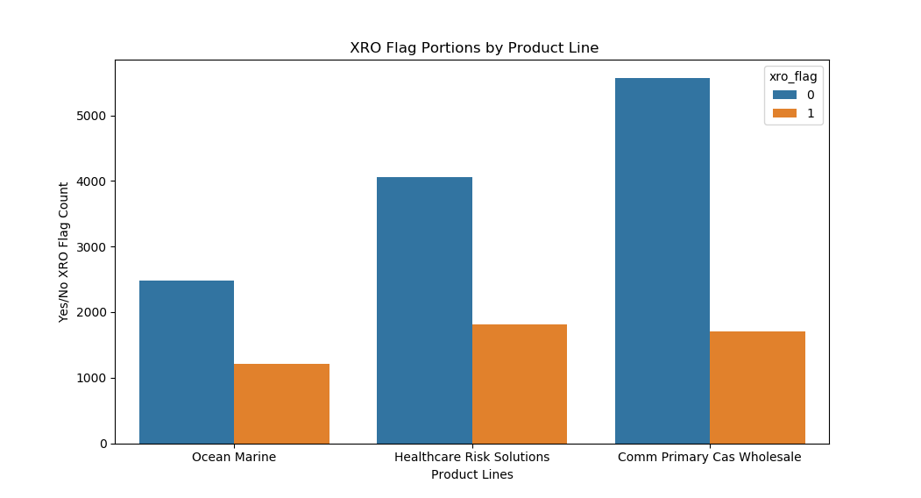XRO Flag Portions
  + Binding P&C ≈ 0.0%
  + Commercial Primary Casualty Wholesale ≈ 25.6%
  + Healthcare Risk Solutions ≈ 33.7%
  + Ocean Marine ≈ 35.2%

Brokerage Casualty Rate Guidance Analysis

* 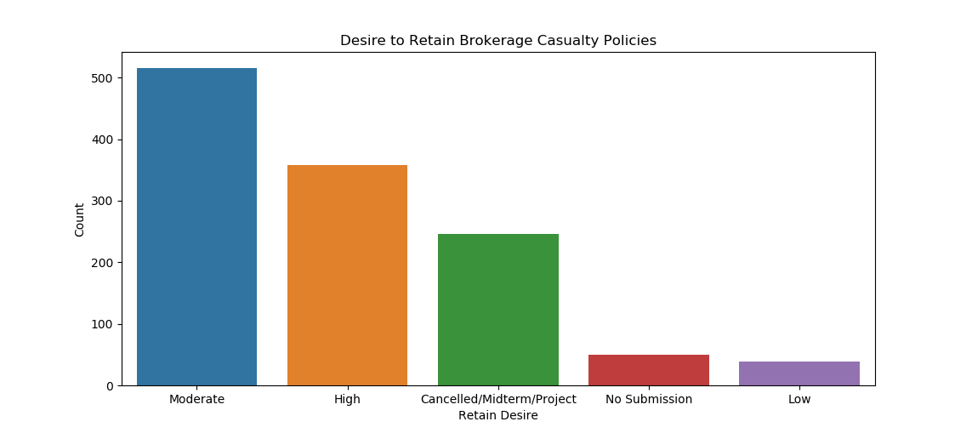Although the count of “Low” desire to retain policies seems fruitless, the underwriters spend most of their time on these policies because they are the ones at most risk
  + 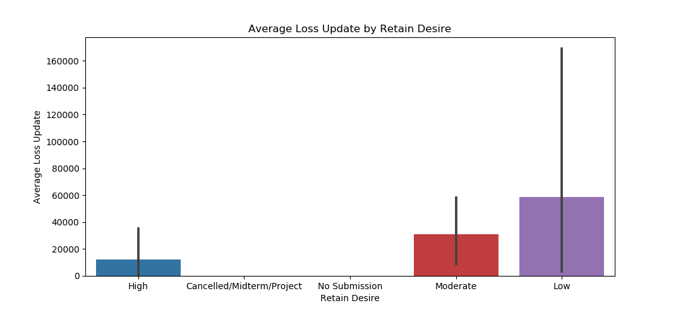Updating different policy attributes like loss, premium, rate floor, etc.

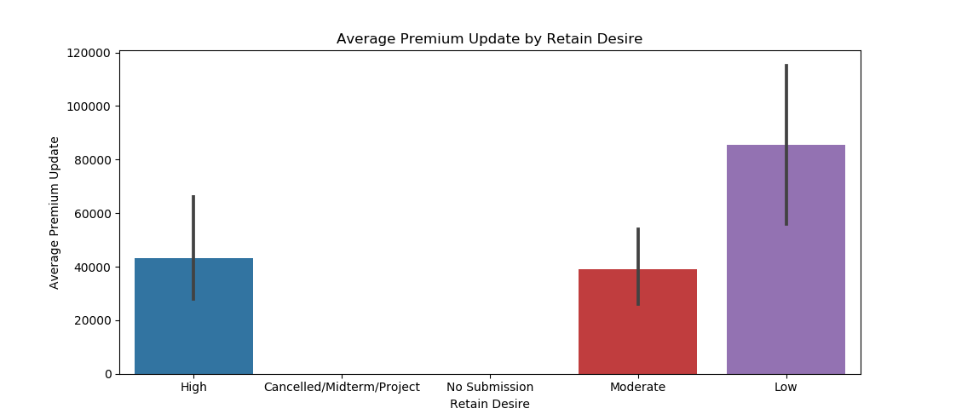

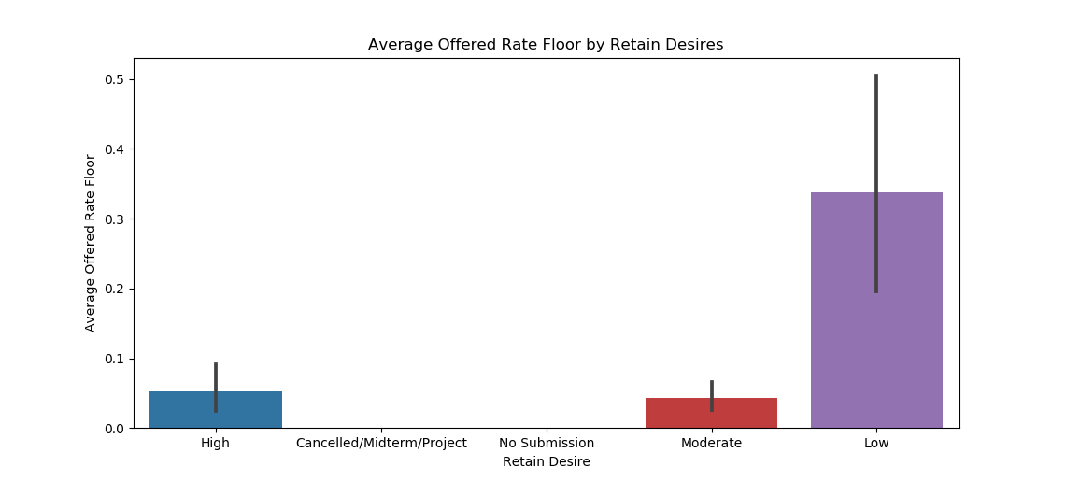

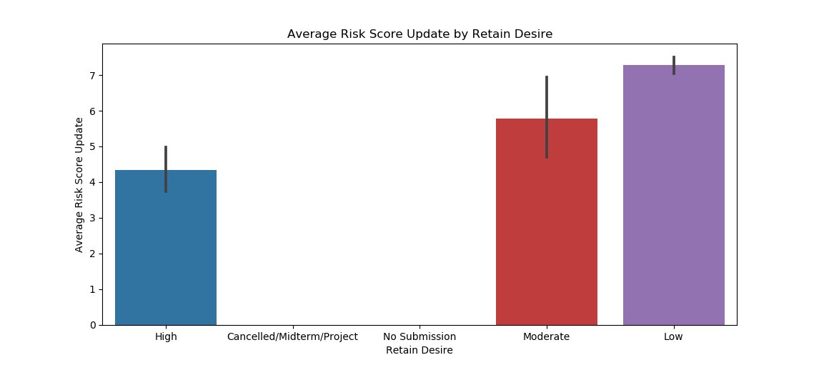

* Evidently, these “Low” desire to retain policies are high priority for the underwriters in terms of workflow and require extended thought, something that can be facilitated by the underwriter workbook’s rate calculator

Time Savings and GWP Analysis

“Best thing Markel has done for my work since starting here” – Ryan Boyd

“Vast improvement” – Darwin Kroll

“Definitely saves us a lot of time” – Anita Odle

* Viz below represents an estimate of the total time spent on the high priority policies in terms of workflow (policies with claims) for each product line based on premium & loss survey data we received from talking to underwriters
  + Commercial Primary Casualty Wholesale
    - Time spent on policy before workbook ≈ 20 min
    - Time spent on policy after workbook ≈ 5 min
  + Healthcare Risk Solutions
    - Time spent on policy before workbook ≈ 60 min
    - Time spent on policy after workbook ≈ 5 min
  + Ocean Marine
    - Time spent on policy before workbook ≈ 20 min
    - 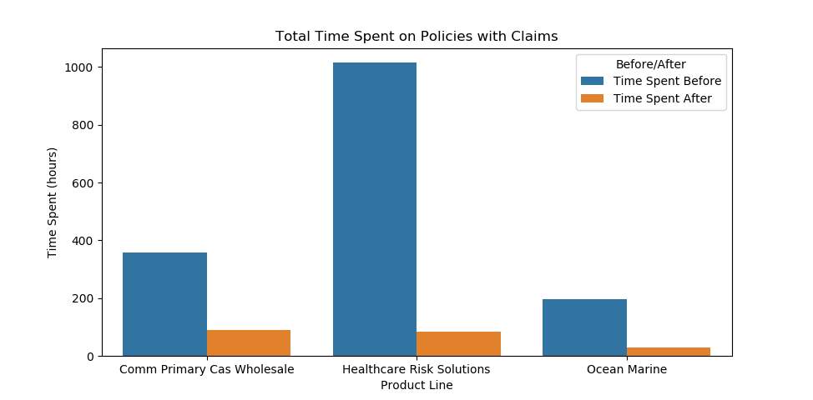Time spent on policy after workbook ≈ 3 min
* Time Savings
  + Commercial Primary Casualty Wholesale ≈ 300 hours
  + Healthcare Risk Solutions ≈ 900 hours
  + Ocean Marine ≈ 170 hours
* 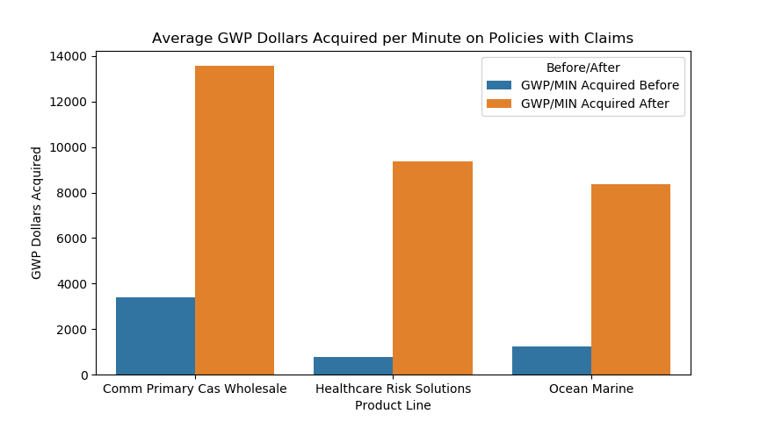Viz below represents an estimate of the efficiency of the workbook by presenting a GWP acquired by minute metric (GWP / MIN) on high priority policies in terms of workflow (policies with claims)
* Acquired GWP
  + Commercial Primary Casualty Wholesale ≈ $10,000 GWP/minute
  + Healthcare Risk Solutions ≈ $8,500 GWP/minute
  + Ocean Marine ≈ $7,000 GWP/minute